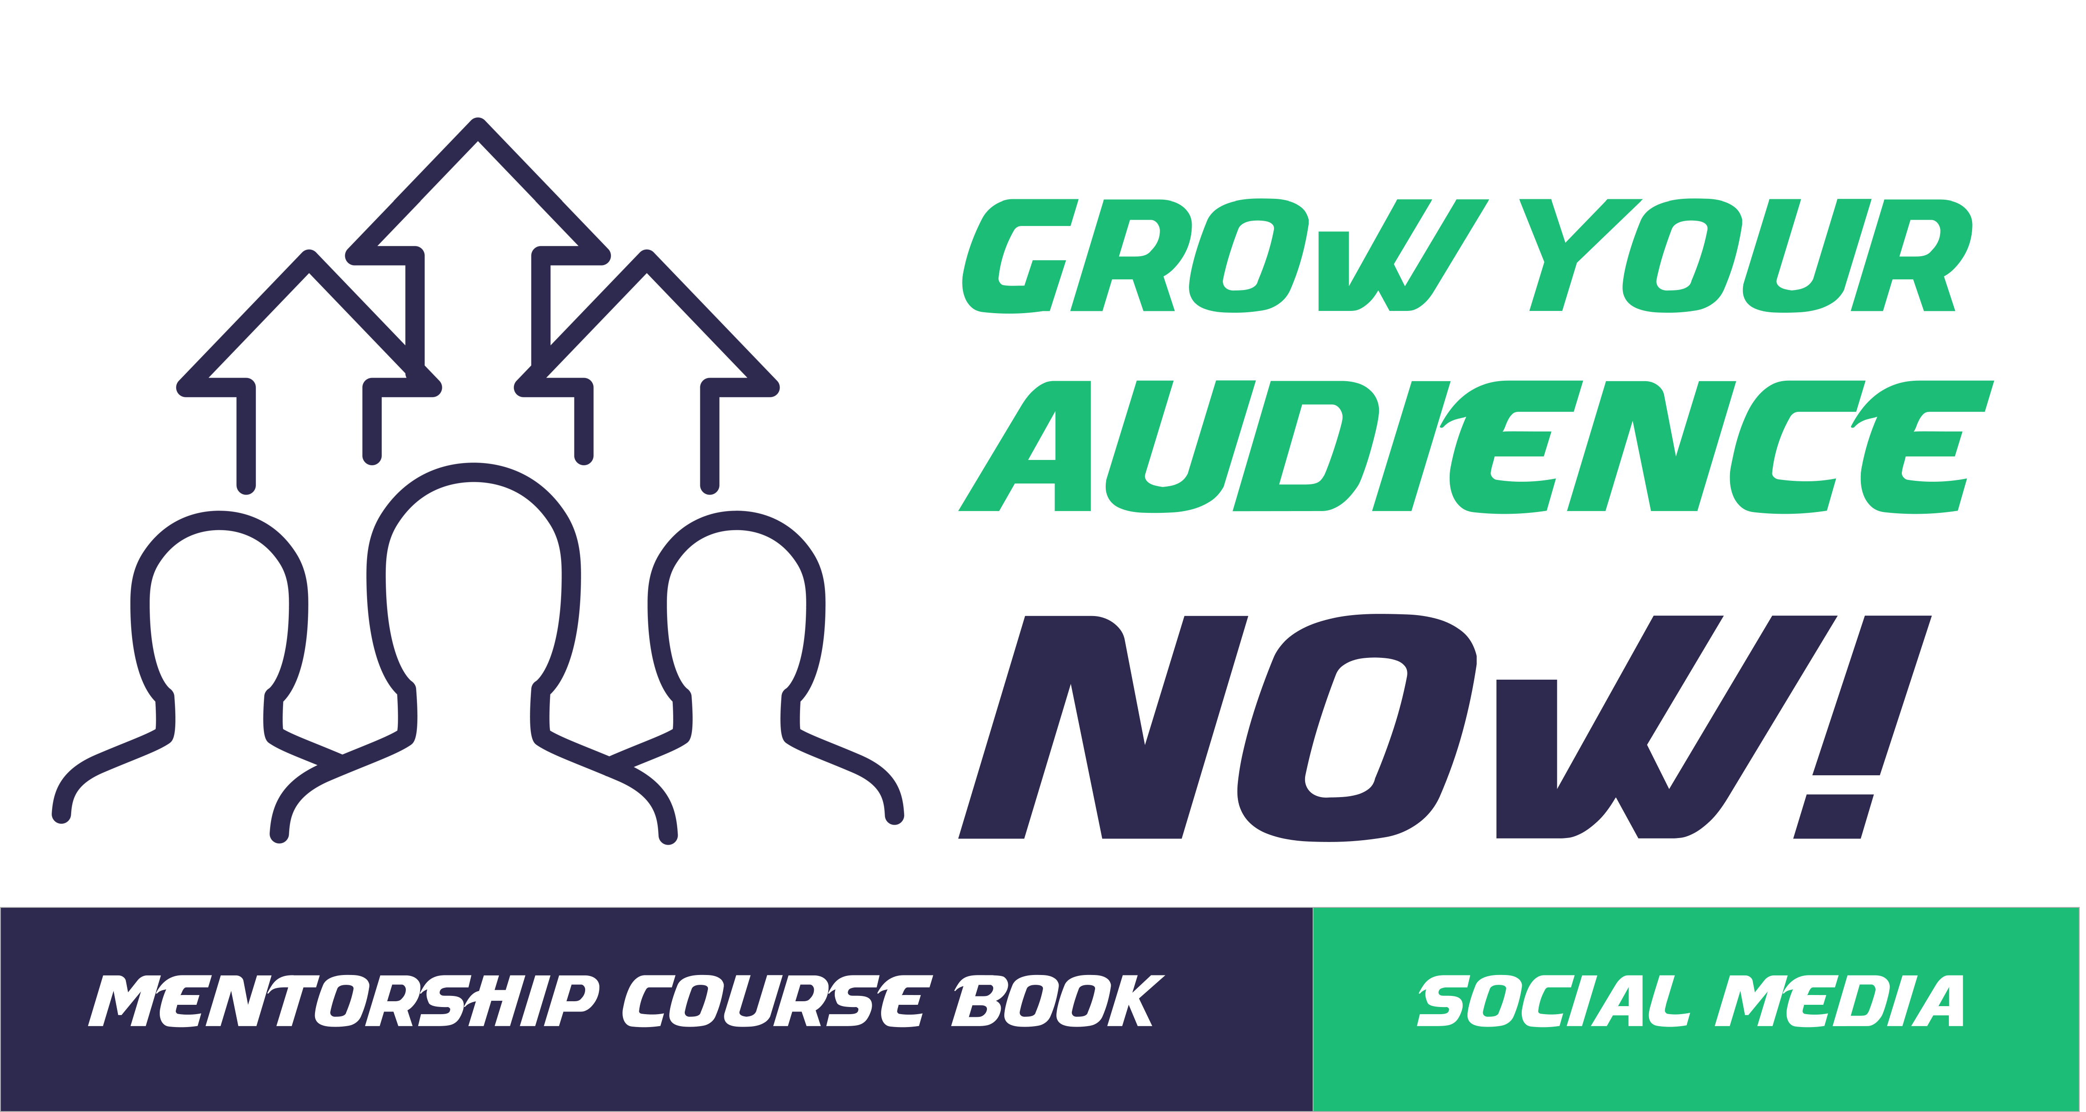

Action Guide

Table of Contents

How to Use Your Action Guide 3
Module 1 – Get Ready to Grow Your Audience 5
Lesson 1: Why Grow an Audience Using Social Media 6
Lesson 2: Set Up for Audience Growth 9
Module 2 – Step 1: Get to Know Your Audience 13
Module 3 – Step 2: Attract Your Ideal Audience 17
Lesson 1: Build Your Audience 18
Lesson 2: Use Social Media to Build Your Email List 22
Module 4 – Step 3: Engage and Nurture Relationships Before You Sell 24
Module 5 – Optimize Your Audience Growth 30
Module 6 - Review and Refine 32

How to Use Your Action Guide

You’ll get the best results from any course you participate in by completing the Action Steps at the end of each module. They will help you apply what you learn directly to your business and your life, maximizing the investment you’re making.
Use the following Action Guide to record your answers, insights, and other notes for the Action Steps, which are outlined in your Course Book. You’ll want to refer to each module’s content as you complete the related steps.
While we have left space in the guide for each action step, you may feel more comfortable using a separate notebook or digital application for your work. Use whatever method you feel most comfortable with and don’t feel constrained to using the space in the Action Guide alone.

In addition, your course may have other Action Sheets, such as spreadsheets or planning templates, which are separate from the guide. Look out for those with your other course materials.
Finally, you don’t have to complete all the steps at once. Instead, try setting a specific time on your calendar to work on them. And don’t feel that you have to get it right the first time. Learning is a process that happens as you apply your new skills and knowledge. You’ll want to return periodically to your Action Guide and both remind yourself of the work you’ve achieved and edit your answers as you see their impact.
Have fun with it and enjoy the progress and successes that will happen as a result of your work!

Introduction

Expectations
Before we start the course, take a minute to think about what you want to get out of it.
Write down three skills you expect to gain.

1
2
3

Module 1 – Get Ready to Grow Your Audience

Lesson 1: Why Grow an Audience Using Social Media

Lesson 2: Set Up for Audience Growth

Lesson 1: Why Grow an Audience Using Social Media
- What do you need an audience for? Be specific in your answer.

- Set an initial goal for size of audience on social media.

- Write down how you feel/think about building an audience on social media.
Negative Thoughts | Positive Thoughts
Reframe any current negative thoughts into positive ones.

- Write 3 affirmations you can use daily.
1.
2.
3.

Lesson 2: Set Up for Audience Growth
- Complete the Audience Building Checklist to see what you have in place and where gaps are.
- Write a description of your ideal customer.

- Outline your main offer for your target audience.

- Make any necessary changes to your social media profiles so that the descriptions are consistent with your offer and UVP and include a link to your opt-in page.
Notes

- Important – If you don’t have it already, set up an email provider, design an opt-in box/page, and create a one-page lead magnet that is delivered to people after they opt-in.
While setting up a list-building lead magnet funnel is not covered in this course, it’s important to have one set up when doing your social media audience building. So be sure to spend time setting up at least a small lead magnet and email list, so you can get the most benefit from your efforts.
Task | Date Completed
Set up an email provider
Design an opt-in box / page
Create a one page lead magnet

Module 2 – Step 1: Get to Know Your Audience
- Research your audience.
What are their biggest challenges?
What specific language do they use about their dilemmas?
Whom do they follow?

How do they consume information? E.g. video, podcast, publications, blog posts
Review your data - Does this match up with what you thought before?
Revise your offer/messaging/ profiles /pages etc., if necessary. Update the audience definition you recorded in last module.

- Competitor research:
Which platforms do they use most?
Content: What type of content do they use on the platforms?
Engagement: How many likes, comments, shares do they have?
Post Frequency: How many times a day/week do they post content?

- Choose two social media platforms to focus on.
Platform 1:
Platform 2:

 | Platform 1: | Platform 2:
Why is this platform suitable for your business?

Module 3 – Step 2: Attract Your Ideal Audience

Lesson 1: Build Your Audience

Lesson 2: Use Social Media to Build Your Email List

Lesson 1: Build Your Audience
- Choose three tactics for growing your audience for each of your 2 chosen social media platforms:
Platform  1 | Tactic 1: | Tactic 2: | Tactic 3:
What do you hope to achieve?
How will you measure your success?
What results are you seeing for each tactic?
Platform  2 | Tactic 1: | Tactic 2: | Tactic 3:
What do you hope to achieve?
How will you measure your success?
What results are you seeing for each tactic?

- Write down a profile of what would make you an attractive guest on someone else’s blog, webinar, livestream, or podcast.

Find at least two potential opportunities for guest speaking/blogging

Follow the businesses on social media
Create any publicity materials you need
Submit your request for interview/post and follow up if necessary

Keep ‘before and after’ stats on social media so you can see the effect of the interviews and posts on your audience figures.
Before stats
After stats

Lesson 2: Use Social Media to Build Your Email List
- Prepare and post the two blog posts as suggested in this module to augment your current content:
Take the problem-solving blog post that points to your lead magnet and post it to all your social media platforms.
@mention the industry experts you added to your Twitter list or blog post on Twitter, letting them know about it. Spread this out by mentioning a few people each day.

- Record your metrics under the headings of:
Likes, Shares, and Comments

Audience Growth #s (Followers and Subscribers)
Credibility (Followers vs Following)
How have your numbers increased because of your actions so far?

Module 4 – Step 3: Engage and Nurture Relationships Before You Sell
- Write at least two engaging follow-up emails that people will receive after they download your lead magnet.
Email
1
Email
2
- Use the Social Media Content Planner to plan what content and activities you’ll do to build engagement on your chosen social media platforms. Then
  - Research the best times to post to your audience and note that in the Social Media Content Planner.
  - Schedule your posts in advance where possible.
- (Optional) Follow the 10 steps in the lesson to design a short Facebook Group challenge event.
Step 1
Set your objective and start date
Step 2
Identify exactly what you will be challenging people to do
Step 3
Create a closed Group on Facebook and a registration opt-in page
Step 4
Schedule a follow-up email series that will trigger when they opt-in, including a link to the Facebook Group
Step 5
Plan your content and how you’ll deliver it
Step 6
Promote your challenge

Complete steps 7-9 when you run the event:
Step 7
Day 0 - Go live, welcome people, and get them ready
Step 8
Days 1 to 5 - Use live video every day to give instructions
Step 9
Days 6 & 7 - Start to promote related paid offers to participants

Finish Step 10 when the challenge is over:
Step 10
Help participants evaluate their progress during the challenge

Module 5 – Optimize Your Audience Growth
- Write down three ways you could customize your opt-in pages for your chosen social media platforms.
Platform 1:
1.
2.
3.

Platform 2:
1.
2.
3.
- Have you considered paid advertising on social media? If so, which platform(s) and what is your budget?
Platforms
Budget

- Make sure you have the essentials in place before you promote any offers.
Sales page
Shopping cart
Payment methods

Module 6 - Review and Refine
- Write down what your current policy is on:
Referrals
Affiliates

How could you incorporate these into your business to build your audience?
Referrals
Affiliates

- Review the course thoroughly and use the action plan table below to record your goals and what needs to happen next.
 | Action to Take | Action Deadline
1
2
3
4
5
6
7
8
9
10

